<https://angular-ui.github.io/>

<https://angular-ui.github.io/bootstrap/>

<https://angular-ui.github.io/bootstrap/#/typeahead>

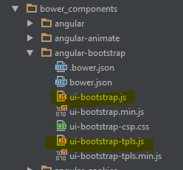

TPLS.JS já vem com os detalhes.

No App.js

**var** app = angular.module('app', ['ngRoute', 'angular-oauth2', 'app.controllers', 'app.services',  
 'app.filters', 'app.directives','ui.bootstrap.typeahead']);

App.blade

<script src="{{ asset('build/js/vendor/angular-messages.min.js') }}"></script>  
<script src="{{ asset('build/js/vendor/ui-bootstrap-tpls.min.js') }}"></script>  
<script src="{{ asset('build/js/vendor/navbar.min.js') }}"></script>

Gulpfile

config.build_path_js = config.build_path + '/js';  
config.build_vendor_path_js = config.build_path_js + '/vendor';  
config.vendor_path_js = [  
 config.bower_path + '/jquery/dist/jquery.min.js',  
 config.bower_path + '/bootstrap/dist/js/bootstrap.min.js',  
 config.bower_path + '/angular/angular.min.js',  
 config.bower_path + '/angular-route/angular-route.min.js',  
 config.bower_path + '/angular-resource/angular-resource.min.js',  
 config.bower_path + '/angular-animate/angular-animate.min.js',  
 config.bower_path + '/angular-messages/angular-messages.min.js',  
 config.bower_path + '/angular-bootstrap/ui-bootstrap-tpls.min.js',  
 config.bower_path + '/angular-strap/dist/modules/navbar.min.js',  
 config.bower_path + '/angular-cookies/angular-cookies.min.js',  
 config.bower_path + '/query-string/query-string.js',  
 config.bower_path + '/angular-oauth2/dist/angular-oauth2.min.js',  
];